TEAM: SRI NIKITA DESETTY TRILOK DHANEKULA
SAI SIVA DEEKSHITA CHITHAJHALLU

CAPSTONE PROJECT – UPDATE-1

THE IMPACT OF U.S STOCK MARKET

FLUCTUATIONS ON USD EXCHANGE RATE AGAINST MAJOR CURRENCIES.

BUSINESS QUESTION:
How do the fluctuation in stock market, represented by S&P 500 index, impact the USD exchange rate against major currencies like EUR, JPY, GBP, AUD, CAD

OBJECTIVE:
This research aims to analyze the correlation between the US stock market's daily performance and fluctuations in the USD exchange rate versus chosen major currencies. This approach will help to determine the extent to which stock market movements influence exchange rates, while accounting for other macroeconomic factors. Understanding this link is crucial for investors, international organizations, and financial analysts since currency exchange rates have a direct impact on cross- border transactions, investment returns, and risk management techniques.

BACKGROUND:
Exchange rates for currencies are influenced by various macroeconomic factors, with the performance of the stock market being particularly significant. The performance of the U.S. stock market, indicated by the S&P 500, has a substantial impact on investor sentiment, capital flows, and economic stability, all of which ultimately affect the value of the USD relative to other major currencies. Grasping this connection
offers essential insights for multinational companies, investors, and policymakers who are impacted by changes in currency values.

SIGNIFICANCE:
Changes in exchange rates significantly influence international trade, investment yields, and corporate profits. This research seeks to analyze the connection between stock market variations and USD exchange rates, thereby adding to current literature and providing valuable insights for financial decision-making, risk management, and global business strategies.

DATASET:
To address the business question the project requires a combination of high frequency (daily) and low frequency data (monthly, quarterly) datasets that we have obtained
from various platforms like FRED, YAHOO FINANCE. Each dataset has essential economic, financial indicators which are required for the analysis of the project.

DATA DICTIONARY:
S.  No | Variable Name | Descrip tion | Type | Freque ncy | Relevance | Usage in Analysis
1 | USD/EU R  Exchange Rate | Daily exchange rate of USD  relative to Euro | Contin uous | Daily | Represents USD’s strength against the Euro, an essential currency pair for global  markets and trade. | Dependent Variable: Analyzes how U.S. stock market  fluctuations impact USD against Euro.
2 | USD/JPY  Exchange Rate | Daily  exchange rate of USD  relative to Japanese Yen | Contin uous | Daily | The JPY is a  major safe-haven currency, making USD/JPY highly sensitive to financial market conditions. | Dependent Variable: Observes the impact of U.S. stock market changes on USD strength against JPY.
3 | USD/GB P  Exchange Rate | Daily exchange rate of USD  relative to British  Pound | Contin uous | Daily | The GBP is crucial for trade and investment in Western economies, impacting USD  demand. | Dependent Variable: Assesses how the U.S. stock market influences USD  relative to GBP.
4 | USD/AU D  Exchange Rate | Daily exchange rate of USD  relative to Australia n Dollar | Contin uous | Daily | The AUD is commodity- sensitive, particularly to resource markets, making it relevant in commodity  contexts. | Dependent Variable: Examines how the  U.S. stock market impacts USD in relation to commodity-driven  currencies like AUD.

5 | USD/CA D  Exchange Rate | Daily exchange rate of USD  relative to Canadian Dollar | Contin uous | Daily | CAD is heavily  influenced by oil prices, making it sensitive to U.S. market movements and commodity pricing. | Dependent Variable: Looks at the effect of stock market movements on USD relative to CAD.
6 | S&P 500  Index | U.S.  stock market performa nce indicator | Contin uous | Daily | Reflects U.S.  stock market performance and investor sentiment, which impacts capital flows and USD demand. | Independent Variable: Used to analyze the impact of  U.S. stock market fluctuations on USD exchange rates.
7 | VIX  (Volatility Index) | Market sentiment indicator | Contin uous | Daily | Measures market  volatility; higher levels indicate uncertainty and drive demand for safe-haven currencies. | Control Variable: Accounts for investor sentiment and risk aversion that may influence currency demand.
8 | WTI  Crude Oil Price | Price of West Texas Intermedi ate crude oil | Contin uous | Monthly | Oil prices are  relevant for USD, especially in relation to commodity- driven currencies like CAD and AUD. | Control Variable: Controls for commodity effects on currency value, particularly for CAD and AUD exchange rates.
9 | Gold Price | Price of gold in USD | Contin uous | Monthly | Gold is a safe-  haven asset. During times of uncertainty, investors often shift to gold, impacting demand for USD. | Control Variable: Helps control for safe- haven behavior that may affect USD, especially in volatile markets.
10 | Real GDP | U.S.  Gross Domestic Product | Contin uous | Quarterly y | Indicates overall  economic performance; higher GDP growth strengthens investor | Control Variable: Accounts for the macroeconomic backdrop, which may indirectly influence exchange rates.

confidence in
USD.
11 | CPI  (Consume r Price Index) | Measures inflation in the U.S.  economy | Contin uous | Quarterly | High inflation  may reduce USD value as it affects purchasing power, influencing exchange rates. | Control Variable: Controls for inflation’s effect on USD value, separating stock market influences.
12 | Unemploy ment Rate | Percentag e of unemploy ed individual s | Contin uous | Monthly | The  unemployment rate reflects economic stability, with high unemployment potentially weakening the USD. | Control Variable: Captures economic stability, impacting USD value through investor confidence.

UPDATE-2

LITERATURE REVIEW:
To determine how stock market movements in the United States affect the USD exchange rate versus important currencies, we reviewed many relevant studies that used strong methodology and substantial variable coverage to investigate similar correlations. These studies provide a robust methodological foundation, containing a variety of models and control variables required for a thorough study. We have summarized the selected publications below, emphasizing their significant contributions and relevance to our research.

SIMILAR CONCEPT LITERATURE:

- Tile: Impact of Exchange Rate Fluctuations on US Stock Market Returns

Relevance to Our Analysis:
Because this study looks at the relationship between the S&P 500 and major currency exchange rates (such EUR, JPY, GBP, etc.), it is very relevant to our research on how exchange rates affect the U.S. stock market. Through the use of US-focused currency pairs and models that consider both long-term relationships and volatility spillovers, it provides empirical support.

Method:

  - Unit Root Test: To ascertain whether variables are stationary, the Phillip- Perron technique is utilized.
  - Cointegration Analysis: To identify long-term relationships between exchange rates and S&P 500 returns, the Johansen cointegration model is employed.
  - VAR/VECM Analysis: These models are used to capture short-term interdependencies and determine if fluctuations in exchange rates impact S&P 500 returns.
  - GARCH, EGARCH, and TGARCH Models: The EGARCH and TGARCH models identify asymmetric effects, in which the influence of negative news on volatility may be larger than that of positive news and are used to assess volatility spillovers.

Variables
S&P 500 returns are the dependent variable.
- Exchange rate returns for currencies such as AUD, CAD, EUR, GBP, JPY, and CHF are examples of independent variables.
- Control variables include cointegration terms for long-term relationship analysis and volatility estimates from several GARCH models.

Key findings
- Volatility Spillover: There is strong evidence of volatility spillover from the AUD and EUR to S&P 500 returns, indicating how changes in these currencies may impact returns on the U.S. market.
- Leverage and Asymmetry: The EGARCH model supported asymmetric
effects, which state that the volatility of currency rates affects the volatility of
U.S. stocks in various ways depending on whether the shocks are positive or negative. When evaluating stock market risk in relation to currency swings, this could be crucial.
- Persistence of Shocks: The GARCH analysis shows persistent volatility shocks, indicating that changes in important exchange rates may impact U.S. market stability for a long time. This is an important factor to consider when evaluating the wider economic effects of exchange rate movements.

METHODOLOGY LITERATURE

Testing for Granger causality in panel data:

- Lopez and Weber's (2017) panel Granger causality techniques are extremely pertinent to our topic, which examines how changes in the US stock market affect the USD exchange rate relative to other major currencies. This method enables us to test for causality in a panel data setting where heterogeneity among several currencies or nations must be considered, which is especially helpful given our focus on many currency pairs or economic situations observed over time.
- Our project's main objective is to determine whether changes in the S&P 500 and other U.S. stock market movements have a causal impact on USD exchange rates in a variety of currency situations (such as USD/EUR, USD/JPY, USD/GBP, etc.). In order to take into consideration the distinct elements connected to every currency pair that could otherwise skew the causality findings, the Lopez and Weber framework includes fixed effects. We can better understand whether observed associations are influenced by particular characteristics of individual currency pairs or if they actually reflect causation by adjusting for these cross-sectional variances.
- This approach guarantees the statistical rigor and robustness of our analysis, enabling us to make trustworthy inferences on the causal relationship between the U.S. stock market and exchange rates in various economic contexts. This realization is essential to our work and improves our capacity to meaningfully generalize results. Furthermore, the paper's Stata implementation makes it possible for us to incorporate this sophisticated causality testing into our project, guaranteeing that we are utilizing the best resources for a complex, multi-context research.

The MIDAS Touch: Mixed Data Sampling Regression Models Key Contributions
  - Flexible Frequency Integration: By combining high- and low-frequency data,
MIDAS regression improves model accuracy. When short-term financial factors intersect with longer-term economic indicators, this flexibility is especially beneficial.
  - Nonlinear Distributed Lag Structure: To understand how daily variations (like stock returns) effect slower-moving variables (like exchange rates) over long periods of time, MIDAS includes a nonlinear lag function that represents the cumulative impact of variables over time.

  - Wide Applicability: The MIDAS model, which was first created for financial and economic purposes, may be used in a variety of studies that need the combination of data with varying frequencies. Its versatility also includes
forecasting and a range of analytical goals.

Relevance to Our Project
- Our study, which looks at how changes in the U.S. stock market (daily returns of the S&P 500) affect the USD exchange rate relative to other major currencies, is especially well-suited to the MIDAS model. We can use MIDAS to combine lower-frequency control variables, like monthly interest rates, quarterly GDP growth, or annual inflation statistics, with high-frequency stock market data. This feature enables us to evaluate the short-term impacts of stock market fluctuations on exchange rates while taking into consideration longer- term, more general economic trends.
- Without compromising data fidelity, MIDAS enables us to perform a sophisticated study of both immediate effects and longer-term economic
influences by maintaining the original frequency of each variable. Furthermore, by capturing lagged effects and temporal dependencies between market shifts and currency adjustments, MIDAS's distributed lag structure allows us to analyze how historical stock market movements affect exchange rates across a range of time frames.
- The use of MIDAS in our study improves the depth and robustness of our conclusions by offering a comprehensive understanding of the dynamic interactions between high- and low-frequency economic variables, especially when it comes to the impact of stock market swings on USD exchange rates.

- An Introduction to Vector Error Correction Models (VECMs)

Key Concepts
  - Long-Run Equilibrium and Cointegration: VECMs are intended for time-series data with a cointegrated relationship, in which the variables may stray in the short term but eventually move in tandem towards a stable long-term trajectory.
  - Error Correction Mechanism: When a variable deviates from the long-term connection, the model incorporates an error correction term that quantifies how much it adjusts to return to equilibrium. We can examine the rate and extent of adaptation to transient shocks thanks to this mechanism.
  - Simultaneous Modelling of Variables: VECMs enable the modelling of interdependent variables simultaneously, capturing both long-term adjustments and short-term responses. Because of this characteristic, VECMs are helpful in systems where variables affect one another.

Relevance to Our Project
- Since our project's goal is to examine how changes in the US stock market affect the USD exchange rate relative to other major currencies, the VECM approach is crucial.
Because stock prices and exchange rates are non-stationary, VECM allows us to model both the short-term deviations brought on by market shocks and the long-
term link between these variables. We can determine whether the S&P 500 and the USD exchange rate have a consistent, long-term relationship by using cointegration testing. The VECM methodology enables us to examine the speed and magnitude with which the USD exchange rate returns to equilibrium after brief fluctuations in stock market prices once cointegration has been verified.
- The error correction term is very helpful in our project because it helps us understand how exchange rates react to misalignments brought on by changes in the stock
market. The impact of U.S. financial markets on exchange rates would be highlighted if we discovered that USD exchange rates react quickly to shifts in the S&P 500. This would suggest a robust relationship between stock market performance and currency valuation. Furthermore, VECM enables us to include control factors that are crucial for separating the impact of stock market swings on exchange rates, such as interest rates and market volatility (e.g., VIX).
- All things considered, VECM offers our project a strong analytical instrument that enables us to capture the dual character of short-term swings and long-term dependence in the link between exchange rates and stock market dynamics.

- This approach ensures that our analysis is thorough, capturing both immediate impacts and the tendency of variables to revert to a long-term equilibrium.

References:
- Bhargava, Vivek, and Daniel Konku. “Impact of Exchange Rate Fluctuations on US Stock Market Returns.” Managerial Finance, vol. 49, no. 10, 2023, pp. 1535–57, https://doi.org/10.1108/MF-08-2022-0387.

- Testing for Granger causality in panel data
Lopez, L., & Weber, S. (2017). Testing for Granger causality in panel data. The Stata Journal Promoting Communications on Statistics and Stata, 17(4), 972–984. https://doi.org/10.1177/1536867x1801700412

- The MIDAS Touch: Mixed Data Sampling Regression Models∗
Ghysels, E., University of North Carolina, Santa-Clara, P., The Anderson School, Valkanov, R., & The Anderson School. (n.d.). The MIDAS Touch: Mixed Data Sampling Regression Models. The MIDAS Touch: Mixed Data Sampling

Regression Models. https://rady.ucsd.edu/_files/faculty- research/valkanov/midas-touch.pdf

- An Introduction to Vector Error Correction Models (VECMs)
An Introduction to Vector Error Correction Models (VECMs) · r-econometrics. (n.d.). https://www.r-econometrics.com/timeseries/vecintro/

UPDATE-3

Data Collection Summary:

Successfully collected extensive data spanning from November 1, 2013, to December 31, 2023, for the following variables across major economies (US, UK, Japan, Canada, Euro area, Australia):

- Exchange Rates
- S&P 500 Index
- WTI Crude Oil Prices
- Real GDP
- CPI (Consumer Price Index)
- Unemployment Rate
- VIX
- Gold Price – Export and Import

Data Availability Insights:

S&P 500 Index: Data was available only from November 10, 2014, to November 10, 2023.

Real GDP:
- UK data was available only from November 1, 2013, to July 1, 2020.

CPI:
- Euro area data ranged from November 1, 2013, to January 1, 2023.
- Japan data spanned from November 2, 2013, to June 1, 2021.
- Australia data was only available for a short period from November 1, 2013, to October 1, 2013 (likely a data collection or alignment issue).

Unemployment Rate:
- Euro area data spanned from November 1, 2013, to January 1, 2023.
- UK data was available only from November 1, 2013, to December 1, 2016.

Data Quality Considerations:

Missing Values: The data contains periods with missing observations due to varying data collection dates and the frequency of available data across different sources.

Potential Handling Strategy:
  - Interpolation: For some variables, linear interpolation may be applied to estimate missing values where feasible.
  - Exclusion: Periods with insufficient data for reliable estimation will be excluded from the analysis to ensure the integrity of results.

Outliers: Initial analysis has flagged some potential outliers.
  - Treatment: Z-score or IQR methods will be used to identify and potentially adjust or exclude significant outliers to mitigate skewed insights.

Exploratory and Descriptive Analysis:

Visualizations:
  - Time series plots for each variable to observe trends over the entire period.

Summary Statistics:

- Calculated percentage changes and relative differences to standardize the datasets for comparative analysis.

Next Steps:

Outlier Analysis:
- Further assess outliers using robust statistical methods and decide whether transformation or exclusion is appropriate.

Missing Value Imputation:

- Finalize imputation strategies, particularly for GDP and CPI datasets that exhibit significant gaps.

Predictive Modeling Preparation:

- Ensure the cleaned dataset is ready for time series modeling or regression analysis to forecast economic trends and variable impacts.

Challenges and Limitations:
Data Incompleteness: The gaps in data for some variables, such as the shorter time span for UK Real GDP, may limit comprehensive analysis over the entire study period.

Currency and Exchange Rate Volatility: The inclusion of diverse exchange rate data necessitates careful normalization and multivariate analysis to account for global macroeconomic shifts.
Summary:
The data collection phase is complete, and initial data cleaning and analysis processes are underway. The project is progressing as planned, with the focus now shifting to data treatment (outlier and missing value handling) and further exploration before advancing to predictive and prescriptive modeling.

UPDATE -4

1. Data Collection and Sources

Primary Data Sources:
  - Exchange Rates: Collected USD exchange rate data for Australia, Canada, Euro, Japan, and the UK.
  - SP500 Index: Daily stock market data that reflects the performance of 500 major U.S. companies, sourced to understand how market trends impact exchange rates.
  - VIX (Volatility Index): Represents the market's expectations of future volatility, providing insights into market sentiment.
  - Unemployment Rates: Monthly unemployment rates for the USA, Australia, Canada, Eurozone, Japan, and the UK were gathered to assess economic health and labor market conditions.
  - Real GDP: Quarterly Real GDP data for the selected countries were sourced to evaluate economic output and its effect on exchange rates.

  - Commodities:
    - Crude Oil Prices: Monthly global oil prices data were included to examine the influence of energy costs on currency values.
    - Gold Prices: Monthly gold export and import data to observe the impact of global commodity pricing on currency movements.

Note: Data for the Consumer Price Index (CPI) for Australia was not available, which has resulted in the CPI for Australia being excluded from this phase of the analysis.

2. Data Preprocessing and Cleaning

Initial Steps:
  - Data Import: Utilized the `readxl` library in R for importing datasets. This ensured that data was cleanly read into R for further processing.
  - Time Formatting: Reformatted observation dates across all datasets to remove time components, standardizing them to a common date format (YYYY-MM-DD).

Data Cleaning:
  - Missing Values Analysis:
    - Checked for `0`, `NULL`, and blank cells to identify and quantify missing values.
    - Removed rows with missing data for essential variables, ensuring data consistency while retaining a backup of the original dataset.
  - Column Naming: Updated column names to make them descriptive, which helps in ensuring clarity during analysis.

3. Frequency Conversion

Monthly and Quarterly Data Conversion:
  - Objective: Standardize all datasets to daily frequency for uniform time-series analysis.
  - Approach:
    - Monthly Data (Unemployment Rate, Crude Oil Prices, Gold Prices): Transformed monthly data into daily data by filling in each month's value for all days in that month.
    - Quarterly Data (Real GDP): Expanded each quarter's value to cover all days in the respective quarter.
  - Outcome: This conversion provided a consistent daily dataset across all economic indicators, enabling accurate day-by-day comparisons and analysis.

4. Merging Datasets

Key Merging Steps:
  - Country-Specific Data: Merged unemployment rates, exchange rates, and Real GDP with country identifiers using `Country_ID` to distinguish between different countries.
  - Global Data Integration: Combined non-country-specific data (SP500, VIX, Crude Oil, and Gold Prices) uniformly across all countries, ensuring that redundant columns were avoided.
  - Merged Dataset Composition: The merging process maintained the chronological sequence of each country, resulting in a dataset structured for comprehensive, time-series analysis without redundant date or country entries.

5. Feature Engineering

- Percentage Change and Relative Difference:
  - Purpose: To provide a more dynamic view of the data by calculating the rate of change between consecutive observations.
  - Implementation:
    - Percentage Change: Calculated as the change relative to the previous observation to show the trend in variable values.
    - Relative Difference: Computed as an absolute value to highlight the scale of change without directional bias.
  - Special Handling for Monthly and Quarterly Data:
  - Excluded `0`s in the calculations for monthly and quarterly data (Unemployment Rate, Gold Prices, Crude Oil, Real GDP) to avoid misleading visualizations and maintain the integrity of the analysis.

6. Data Visualization

Visualizations Created:
- Line Charts and Scatter Plots:
  - Visualized the percentage change and relative difference for key variables (Exchange Rate, SP500, VIX, etc.).
  - Developed separate visualizations for each country to showcase country-specific trends and their relationship with global economic indicators.
- Multi-Variable Comparisons:
  - Created pairwise visualizations to highlight relationships between key economic variables such as Exchange Rate vs. SP500 and Real GDP vs. Exchange Rate.
  - Visualization Strategy:
  - Skipped `0`s in percentage change and relative difference values for visualizations involving monthly and quarterly data to avoid skewed representations.
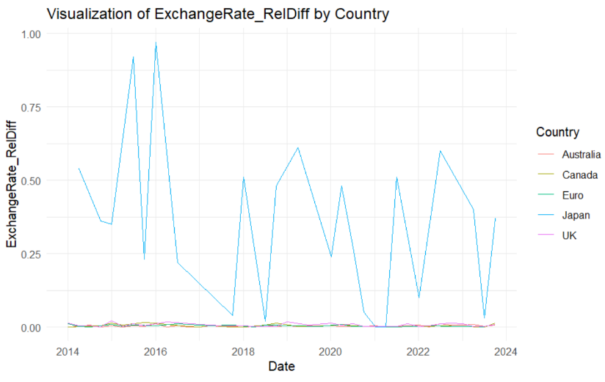
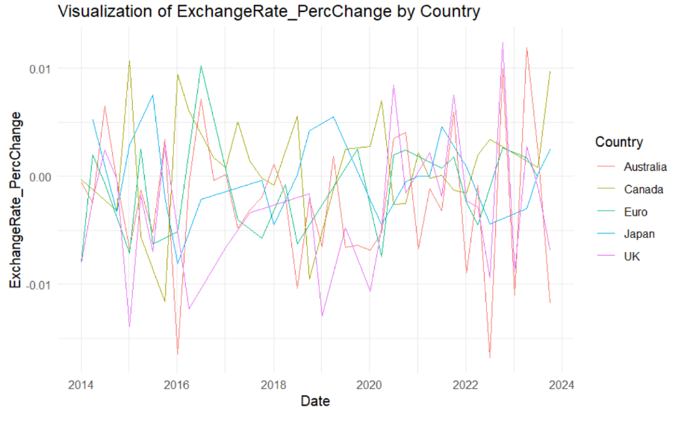

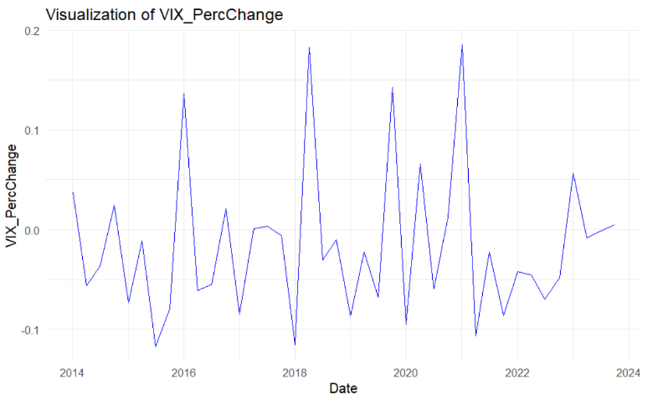
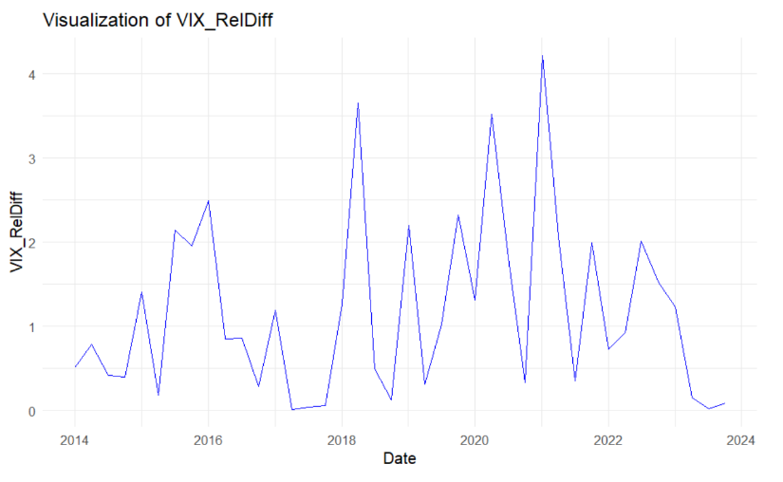
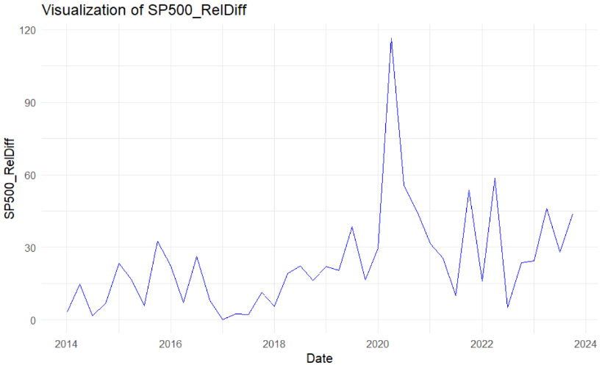
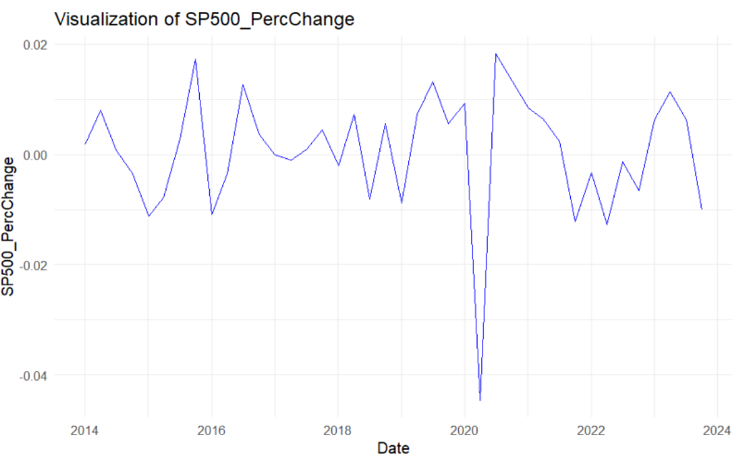
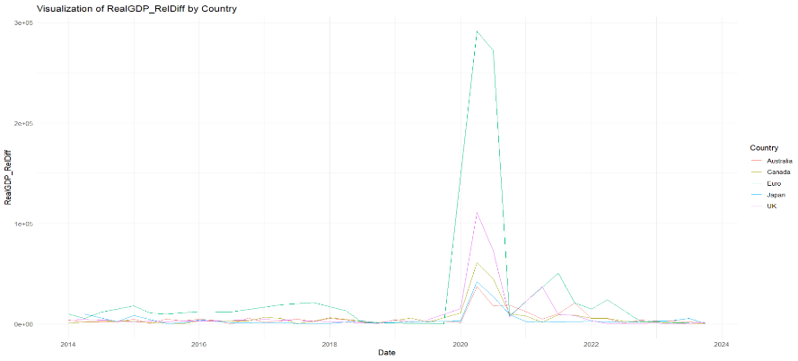
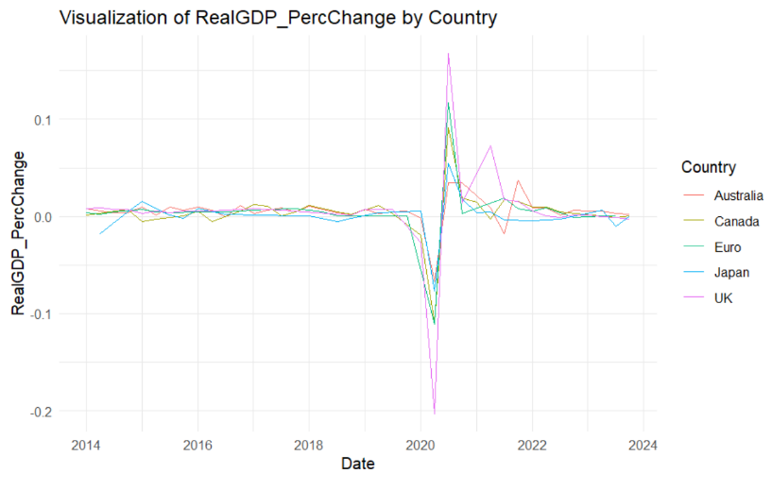
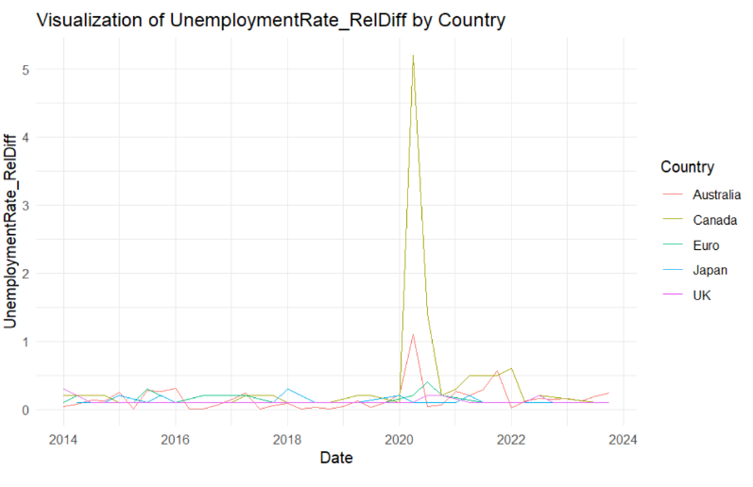
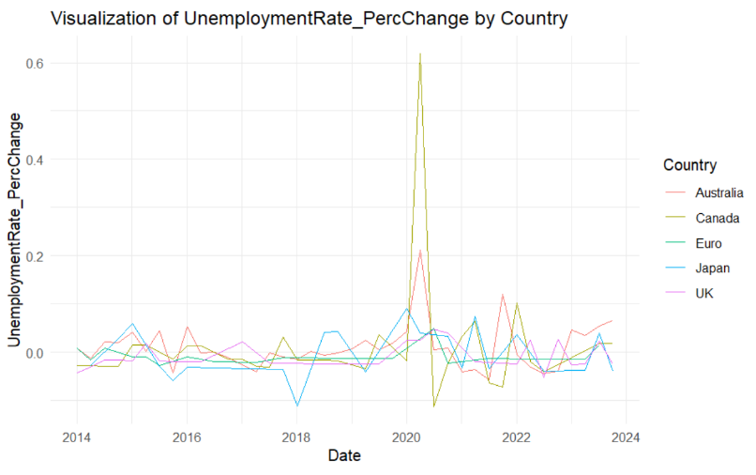
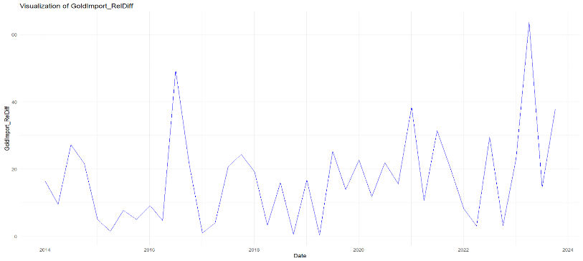
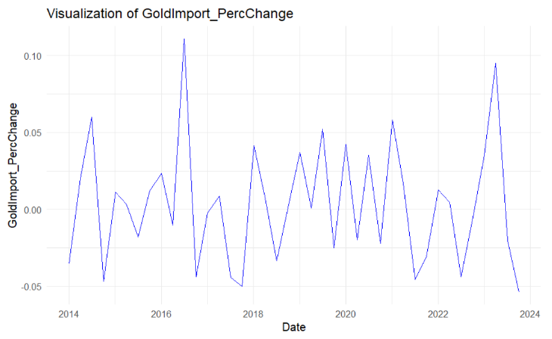
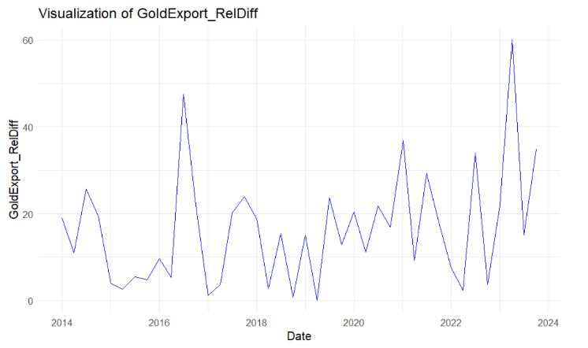
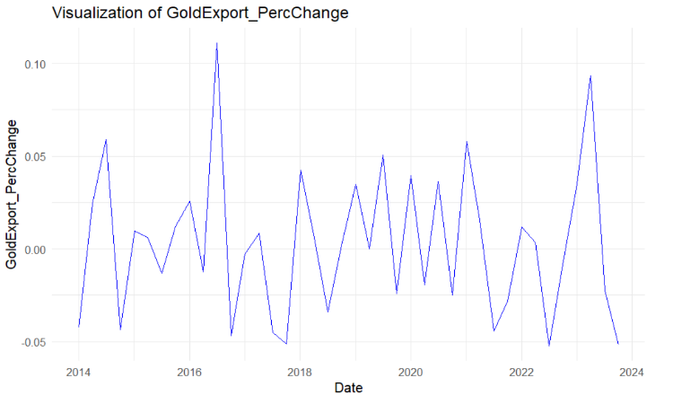
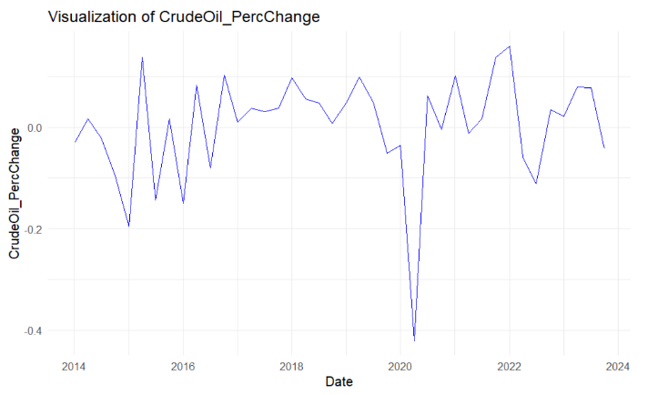
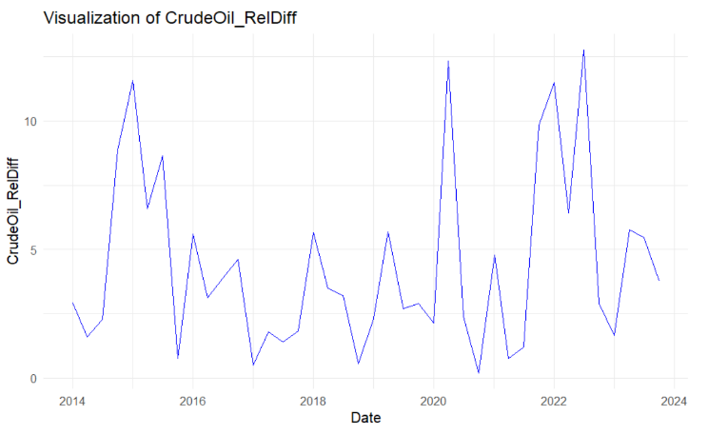
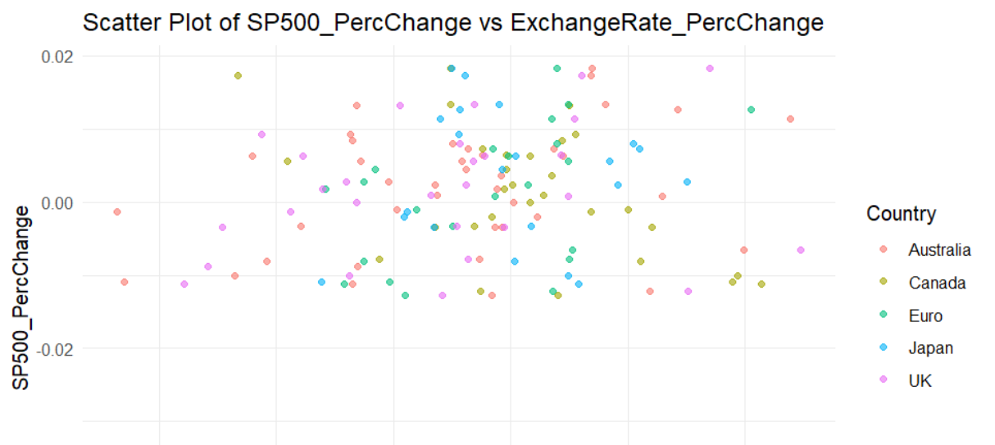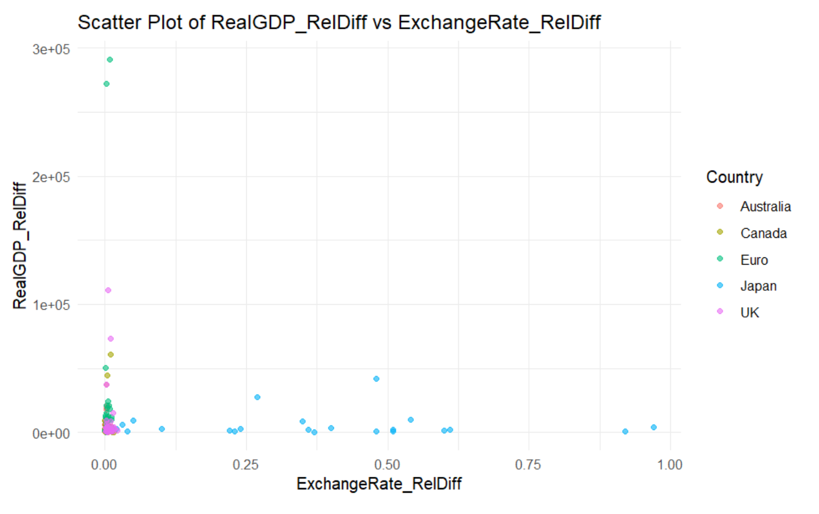
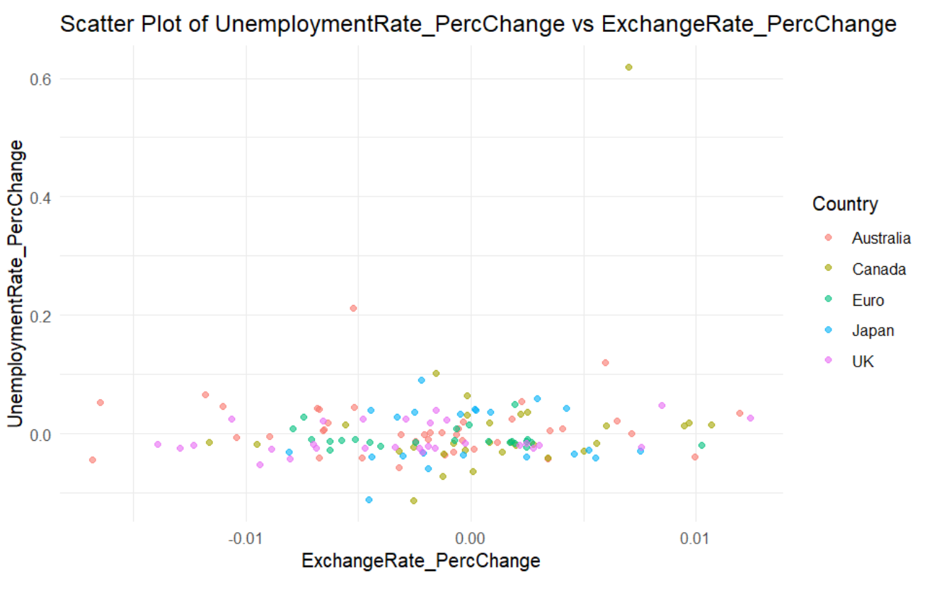
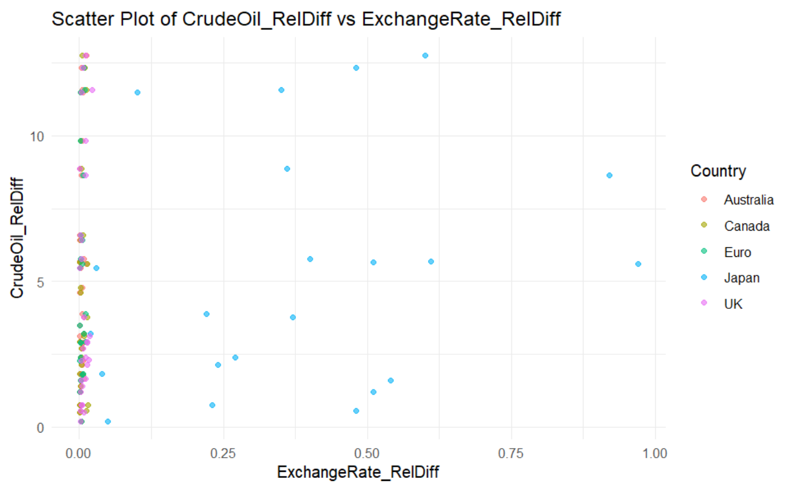
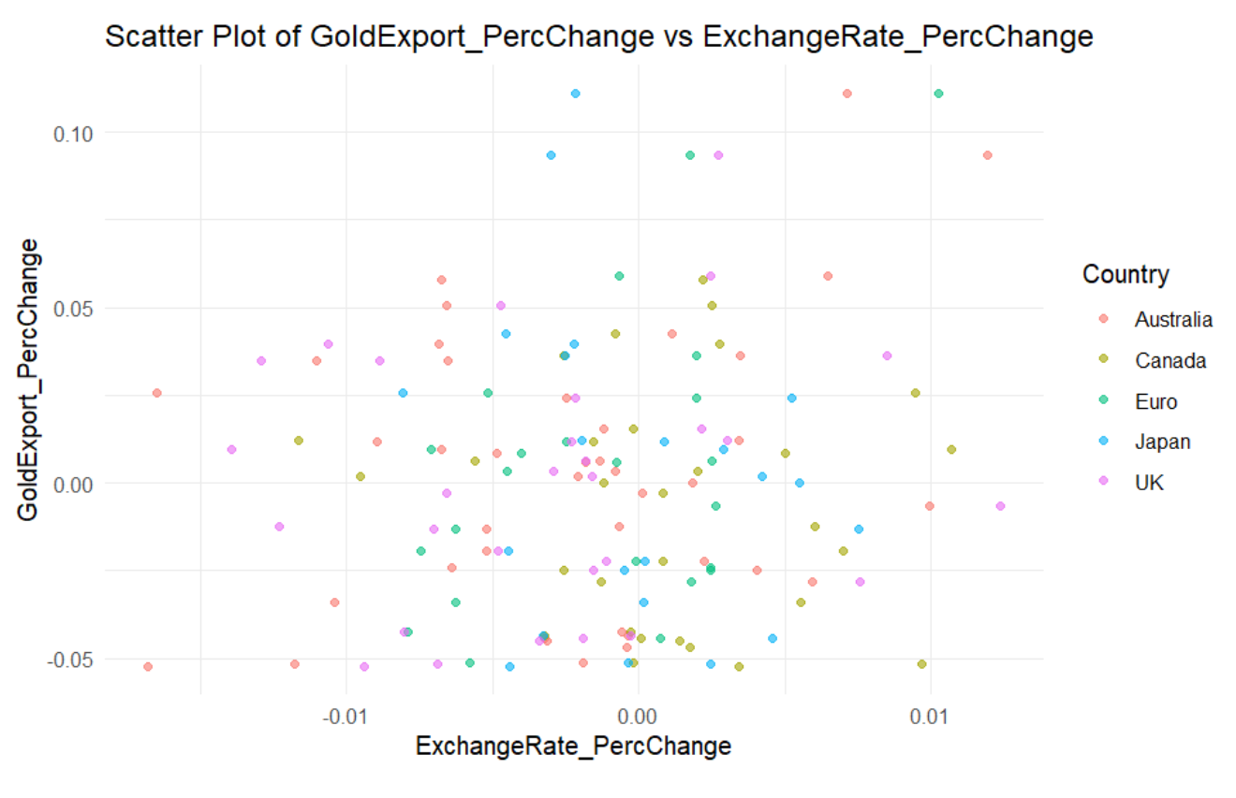
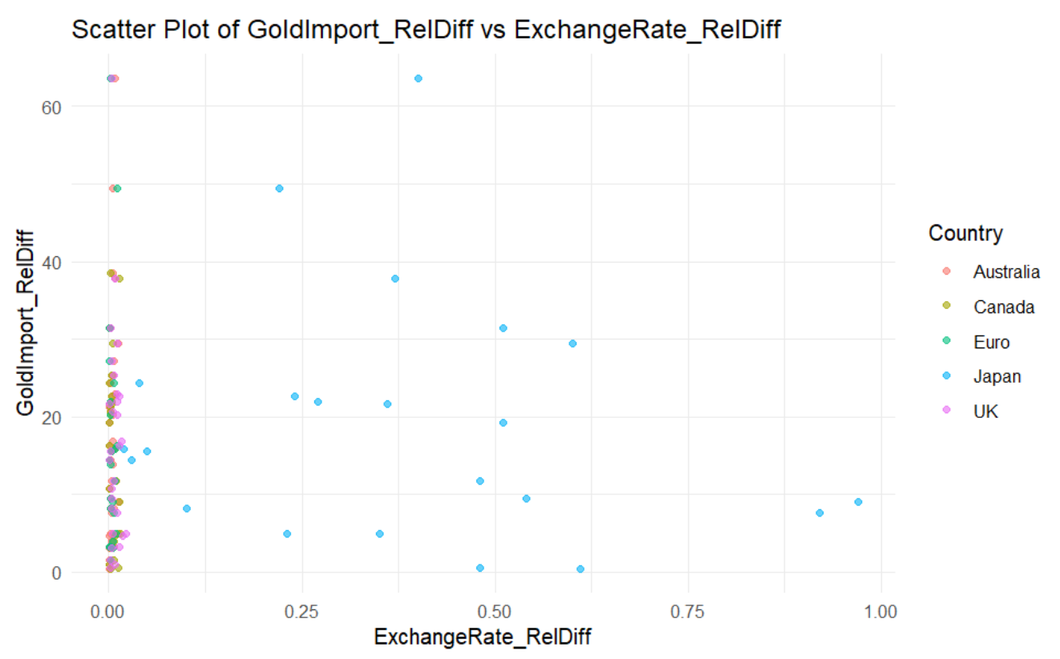
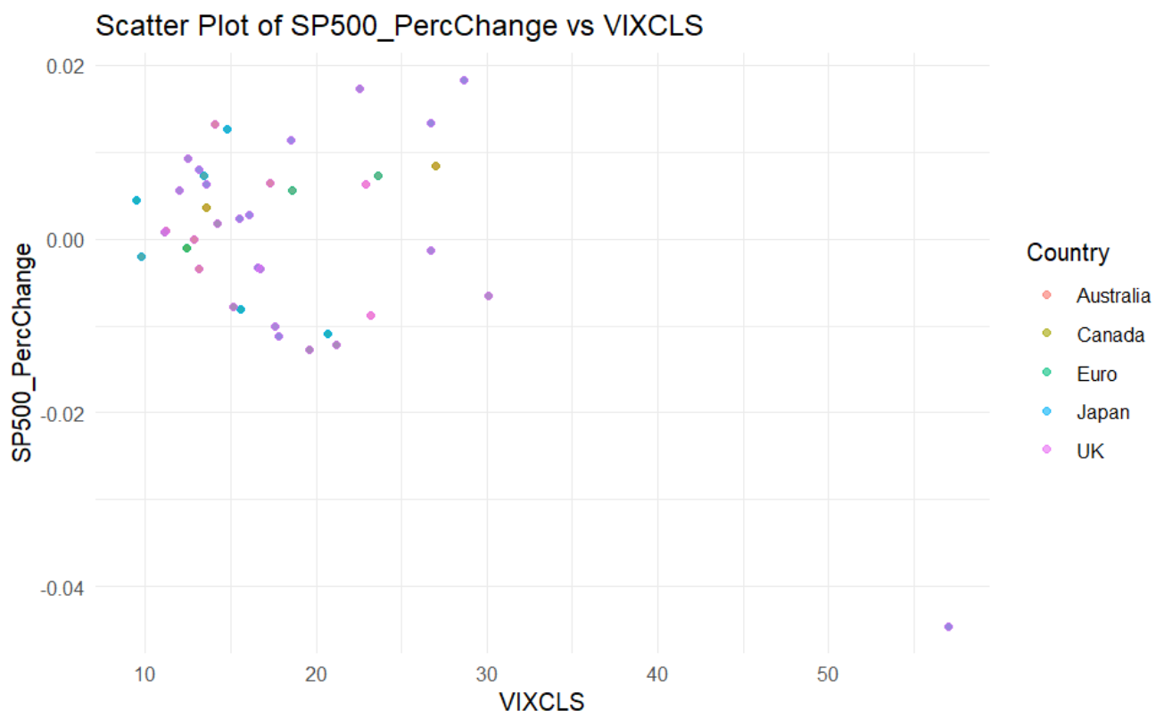

UPDATE-5

1. Data Collection
- Downloaded data for the period from Q4 of 2012 to December 31, 2023, covering the following key economic indicators:
  - Exchange Rate
  - S&P 500
  - VIX (Volatility Index)
  - Crude Oil Prices
  - Unemployment Rate
  - Gold Import Values
  - Gold Export Values
  - Consumer Price Index (CPI)
  - Real GDP

2. Individual Data Processing and Calculations
a. Exchange Rate Data
- Imported data into R and ensured all columns had consistent naming conventions.
- Renamed the Date column to observation_date and standardized it across all datasets.
- Calculated the percentage change in exchange rates for each country.
b. S&P 500 Data
- Loaded data using read_excel() and checked for missing values.
- Renamed relevant columns for consistency (e.g., Date to observation_date).
- Calculated the percentage change in daily S&P 500 values.
c. VIX Data
- Processed VIX data to ensure date format consistency and column alignment.
- Calculated the percentage change in the Volatility Index (VIX) values.
d. Crude Oil Data
- Ensured the Date column was formatted correctly.
- Renamed the crude oil price column to Crude_Oil for clarity.
- Calculated the percentage change in crude oil prices.
e. Unemployment Rate Data
- Preprocessed data for all countries and renamed Date to observation_date.
- Standardized column naming conventions by renaming unemployment rate columns to Unemployment_Rate.
- Calculated the percentage change in unemployment rates for each country.
- Derived the relative difference of each country’s unemployment rate percentage change compared to the US unemployment rate percentage change.
f. CPI Data
- Ensured consistent column naming conventions across all datasets:
  - Renamed the CPI column to CPI (or US_CPI for the USA dataset).
  - Standardized the Date column format to observation_date.
- Calculated the percentage change in CPI values for each country.
- Derived the relative difference of each country’s CPI percentage change compared to the US CPI percentage change.
g. Real GDP Data
- Standardized column names by renaming GDP values to Real_GDP.
- Ensured quarterly data was converted into daily frequency using interpolation techniques.
- Calculated the percentage change in GDP values for each country.
- Derived the relative difference of each country’s GDP percentage change compared to the US GDP percentage change.
h. Import and Export Data
- Processed import and export datasets by renaming columns for clarity (e.g., Imports and Exports).
- Calculated the percentage change in import and export values for each country.

3. Data Processing and Cleaning
- Applied consistent column naming conventions across all datasets:
  - Renamed Date columns to observation_date.
  - Adjusted specific columns for clarity (e.g., POILWTIUSDM to Crude_Oil).

Next Steps:
- Conduct exploratory data analysis (EDA) on the processed datasets to identify patterns and relationships between key economic indicators.

UPDATE-6

Model Implementation
- A rolling prediction function was implemented with the following features:
  - A window size of 29 days was used to train the linear regression model.
  - Predictions for the next day’s exchange rate were made using the variables:
    - SP500
    - VIX
    - RealGDP
    - CPI
  - Rows with missing values in the training window were excluded to maintain data quality.
  - Predicted exchange rates were stored in a new column, Predicted_ExchangeRate.
3. Evaluation Metrics
- The following metrics were calculated to assess the model’s accuracy:
  - Mean Absolute Error (MAE): Measures the average magnitude of errors.
  - Mean Squared Error (MSE): Penalizes larger errors more heavily.
  - Root Mean Squared Error (RMSE): Represents the error in the same unit as the target variable.
  - R-squared: Indicates the proportion of variance in actual values explained by the model.
Results:
- Overall Model Performance:
  - MAE: 0.1903
  - MSE: 0.3882
  - RMSE: 0.6231
  - R-squared: 0.9998
4. Visualization
- Plots of actual vs. predicted exchange rates were created for each country:
  - Line plots compared Actual and Predicted values.
  - Facets by country allowed for easy visual comparison.
Observations
- The model’s performance varied across countries due to differences in economic conditions and data variability.
- Higher RMSE values for some countries indicated larger prediction errors.
- R-squared values provided insight into how well the predictors explained exchange rate variations.

UPDATE-7

Model Implementation and Evaluation
Model 1:
- Implementation Features:
  - A rolling window of 29 days was used to train a linear regression model.
  - Predictors included:
    - Lagged Variables: VIX_lag5, SP500_lag5, CrudeOil_lag5
    - Economic Indicators: CPI, RealGDP, GoldImport
  - Rows with missing values in the training window were excluded to ensure data quality.
  - Predicted exchange rates were stored in a new column, Predicted_ExchangeRate.
Evaluation Metrics
- Mean Absolute Error (MAE): 0.201
- Mean Squared Error (MSE): 0.453
- Root Mean Squared Error (RMSE): 0.673
- R-squared: 0.9997
- Adjusted R-squared: 0.9997
Results
- The model achieved near-perfect R-squared values, indicating strong explanatory power but raising concerns about overfitting.
- Economic indicators like CPI and RealGDP significantly contributed to the predictive accuracy.

Model 2:
Implementation Features:
  - A rolling window of 29 days was used to train a linear regression model.
  - Predictors included:
    - Lagged Percentage Change Variables: VIXPC_lag5, SP500PC_lag5, CrudeOilPC_lag5
    - Economic Indicators: CPIPC, UnempPC, GoldImportPC
  - Rows with missing values in the training window were excluded to maintain data quality.
  - Predicted exchange rates were stored in a new column, Predicted_ERPC.
Evaluation Metrics
- Mean Absolute Error (MAE): 0.00569
- Mean Squared Error (MSE): 0.00130
- Root Mean Squared Error (RMSE): 0.0360
- R-squared: 0.000000315
- Adjusted R-squared: -0.000462
Results
- This model struggled to explain exchange rate variations, as evidenced by the near-zero R-squared and negative Adjusted R-squared values.
- Using percentage change variables did not yield significant predictive power, suggesting the need for additional explanatory variables or a different modeling approach.

Model 3:
Implementation Features:
  - A rolling window of 29 days was used to train a linear regression model.
  - Predictors included:
    - Lagged Variables: VIX_lag5, SP500_lag5, CrudeOil_lag5
    - Economic Indicators: UnemploymentRate, GoldImport
  - Rows with missing values in the training window were excluded to ensure data quality.
  - Predicted exchange rates were stored in a new column, Predicted_ExchangeRate.
Evaluation Metrics
- Mean Absolute Error (MAE): 0.207
- Mean Squared Error (MSE): 0.643
- Root Mean Squared Error (RMSE): 0.802
- R-squared: 0.9996
- Adjusted R-squared: 0.9996
Results
- Similar to Model 1, this model achieved near-perfect R-squared values, indicating strong predictive performance but potential overfitting.
- The inclusion of UnemploymentRate as a feature provided additional insights into labor market impacts on exchange rates.

PLM Model (Panel Data Approach)
- Objective: Incorporate country-specific and time-specific effects to enhance predictive accuracy using panel data.
- Challenges Faced:
  - Data Imbalance: Missing values across countries caused difficulty in maintaining a balanced panel dataset.

